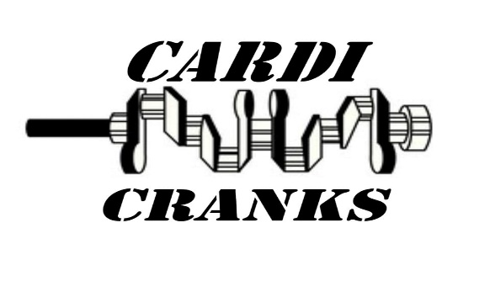Membership form

Membership is annual and will run from October 2023 until October 2024

|  |  |  |  |  |  |
| --- | --- | --- | --- | --- | --- |
| Name |  | | | | |
| Address |  | | | | |
| email |  | | | | |
| Mobile number |  | | | | |
| Landline number |  | | TICK | I understand that Cardi Cranks will only use my information for club purposes | |
| Bank details for membership payment | Cardi Cranks (business account)  Account number **76850978**  Sort code **51-61-06** | |  |
| Official Use Only | Payment  £5 received |  | Membership  Number | |  |

**Areas of interest (Please tick all that apply)**

|  |  |  |
| --- | --- | --- |
|  | **Attend** | **Volunteer/**  **steward** |
| Aberaeron Vintage Show |  |  |
| Car runs |  |  |
| Day Trips |  |  |
| Club Socials |  |  |

|  |  |
| --- | --- |
| Pre 1980 cars |  |
| Future Classics |  |
| Tractors |  |
| Motor bikes |  |
| Stationary engines |  |
| Other (please state) |  |

|  |  |
| --- | --- |
| Sign | Date |

Small print: I agree to abide by the club code of conduct and always show respect for others and the community.

I understand that I am responsible for my own vehicle, and any event I enter is at my own risk. Members must have their own insurance for their vehicle as the club is not liable for any damage to vehicle, persons, or property.